1. GamePlay Class
   1. Removed duplicate code
   2. Each phase of the game play will have a set of player details that needs to be either displayed or assigned to them which is duplicated in all phases.
   3. Hence, it is extracted into a new method setPlayerDetailsForPhase() that is called from each phase

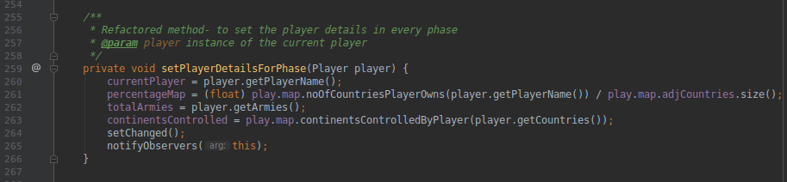

1. Player Class
   1. Extract duplicate code
   2. There is and will be in the future a lot of places where we need to check if a country name given is equal to the country instance’s country name.
   3. There have been 15 occurrences of this code and it has been extracted to a method isCountryNameEquals() that is called from reinforcement() and fortification() to name a few

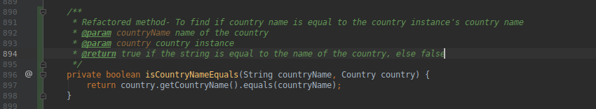

1. Util Class
   1. Extract into a Utility Class for easy access
   2. RandInt() method is a common utility method that can be used in the future which was in RiskMap class
   3. Moved the method to a Util Class and made the method static

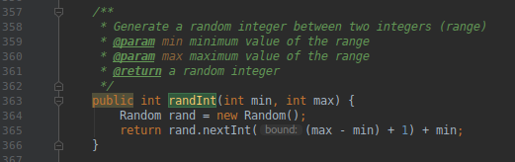

. 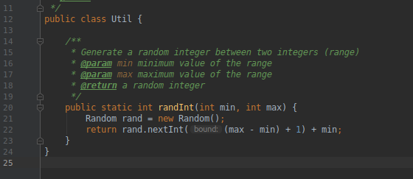

1. Folder Organisation

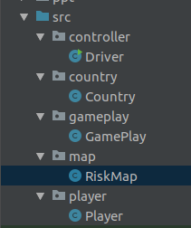  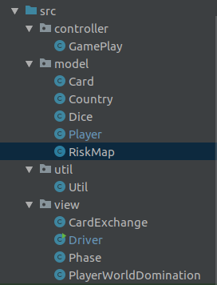

1. Names of variables, classes and methods changed to follow coding conventions and for better understandability